**Ex.No. :1 MEASUREMENT OF FIBER LOSS- OPTICAL FIBER**

**AIM**

To study various type of losses occur in optical fibers and measure the loss in dB of two optical fiber patch cords.

**APPARATUS REQUIRED**

Fiber optic LED light source, Fiber optic power meter, Fiber optic (FO) cable 1 meter, FO cable 5 meter, In line Adaptor.

**FORMULA**

**For measurement of attenuation L = (Pin - Pout) dB**

Where,

Pin - Input power in dB

Pout - Output power in dB

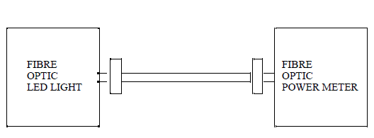

**PROCEDURE**

**Measurement of Attenuation:**

**Step (i)**

Connect one end of the 1 meter FO cable to the FO LED and the other end to the FO power meter.

**Step (ii)**

Plug the AC mains. Connect the optical fiber patch cord scarcely, as shown after relievingall twist and strains on the” Fiber. Note the value on the power meter and note this as *P*01

**Step (iii)**

Wind 4 turns of the fiber on the mandrel as shown in experiment 1 and note the new reading of the power meter *P*02. Now the loss due to bending and strain on the plastic Fiber is P01 -P02.

**Step (iv)**

Next remove the mandrel and relieve the cable twist and strains. Note the reading *P*01 for the 1 meter cable. Repeat the measurement with the 5 meter cable and note the reading *P*03 and *P*04 . Now the loss due to bending and strain on the plastic fibre is *P*03 _ *P*04 dB. Note the reading as P05

P05 _ P01 gives loss in the second cable plus the loss due to inline adaptor.

P05 _ P04 gives loss in the first cable plus the loss due to in-line adaptor.

Assuming a loss of 1.0 dB in the adaptor, we obtain the loss in cable.

**OBSERVATION**

*P*01 = Reading shown by the power meter with 1 m cap

*P*01 =

*P*02 = Reading shown by the power meter at 4 turns of the fiber on the mandrel

*P*02 =

*P*03 = Reading shown by the power meter with 5 m cable

*P*03 =

*P*04 = Reading shown by the power meter at 4 turns of the fiber on the mandrel

*P*04 =

*P*05 = Power meter reading with inline adaptor, first cable and second cable

*P*05 =

**CALCULATION**

Loss due to bending and strain on the plastic fiber (for 1 meter) =P01 ~ P02 = ------------

Loss due to bending and strain on the plastic fiber (for 5 meter) = P03 ~ P04 = -----------

Loss due to in-line adaptor and the second cable =P05 ~ P01 = ------------

Loss due to in-line adaptor and the first cable =P05 ~ P01=---------

**RESULTS**

Attenuation loss in the given Fiber optic cable

1. P01 ~ P02 = _____________dB (loss due to strain)

2. P03 ~ P04 = _____________ dB (loss due to strain)

3. P05 ~ P01 = _____________ dB (Linear loss)

4. P05 ~ P02 = ______________dB (Linear loss)

**Ex.No. :2 MEASUREMENT OF WAVELENGTH OF LASER SOURCE**

**USING DIFFRACTION GRATING**

**AIM**

To calculate the wavelength of given laser light using the diffraction grating.

**APPARATUS REQUIRED**

He-Ne or semiconductor laser source, a transmission grating, an optical bench, screen, meter scale, etc,.

**FORMULA**

The wavelength of laser light is given by

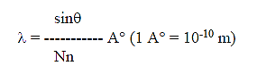

Where,

λ - Angle of diffraction – degree

n – Order of diffraction

N = Number of lines per meter on grating = 105 lines/m



**THEORY**

The wavelength of laser light (LASER – Light Amplification by Stimulated Emission of Radiation) is determined by using the grating. Diffraction means the bending of light rays around the edges of the obstacle. To get the diffraction pattern, spacing between the lines on the grating should be of the order of wavelength of light used. The laser light is allowed to fall on the grating and it gets diffracted. The diffracted rays will form alternate bright and dark fringes and by using Bragg’s equation, the wavelength of laser light is determined.

**PROCEDURE**

The grating is placed between the laser source and the screen. The orientation of the laser in the above set up is adjusted till a bright spot is seen on the screen. This positioncorresponds to the central maximum, and this position is marked on the screen. Next, the screen is moved towards or away from the grating till clear light spots are seen on either side of the central maximum. These light spots on either side of the central maximum correspond to images of different orders of the spectrum. The nearest spots to either side of the central maximum correspond to the image of first order, and the next will correspond to the images of second order and so on. The positions of these spots are also marked on the screen. The distance between the grating and the screen is measured. Let it be‘d’, the distance between the central maximum and first, second, third maximum is measured and so on. The same procedure is repeated on the other side of the central maximum .The readings are tabulated and calculations are done.

Distance between the grating and the screen (d)= ……..x 10-2 m

**TO DETERMINE THE WAVELENGTH OF LASER SOURCE**

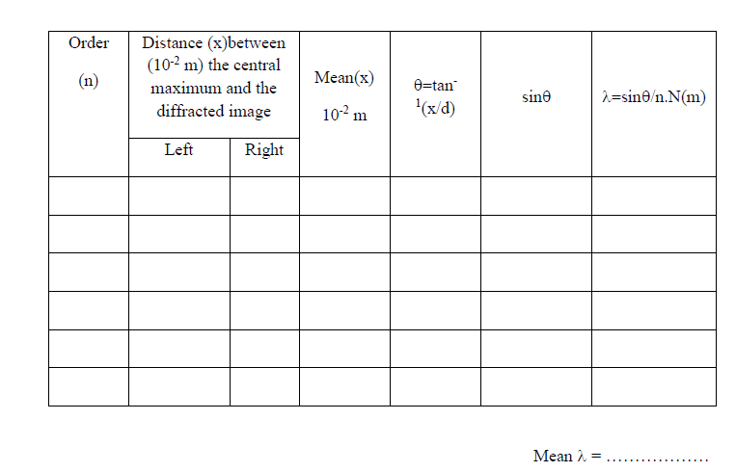

**RESULT**

The wavelength of the given laser light λ = ________m

**Ex.No. :3 MAGNETIC SUSCEPTIBILITY –QUINKE’S METHOD**

**AIM**

To determine the magnetic susceptibility of given liquid using Quincke’s method.

**APPARATUS REQUIRED**

Quincke’s tube with stand, sample liquid (FeCl3), Electromagnet, Constant current powersupply, Digital Gaussmeter, Travelling Microscope, etc.

**FORMULA**

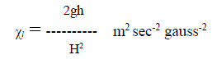

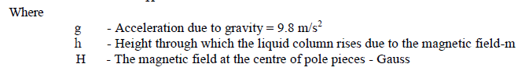

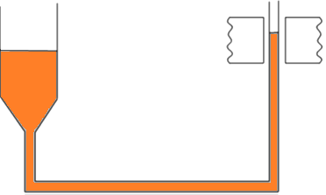

**PROCEDURE**

The apparatus consists of U -shaped tube known as Quincke’s tube. One of the limbs of the tube is wide and the other one narrow. The experimental liquid or solution is filled in the tube and the narrow limb is placed between the pole pieces of the electromagnet. The arrangement is in such a way that the meniscus in the narrow limb is exactly at the centre of the pole pieces and the limb vertical.Focus the microscope on the meniscus and take reading (h1). Apply the magnetic field (H) to its minimum and note its value from the Gauss meter. Note whether the meniscus rises up or descends down. It rises up for paramagnetic liquids and descends down for diamagnetic. Refocus the microscope on liquid meniscus and take reading(h2). Find the difference of two readings to give h = (h1 ~ h2) in m. The experiment is repeated for different values of applied magnetic field (H) by adjusting the variable power supply of the electromagnet. In each case, the rise or fall in the liquid meniscus is noted using the travelling microscope. All the readings are tabulated. From that χ*l*is calculated using the given formula.

**OBSERVATION**

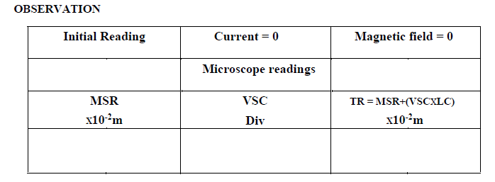

**TO DETERMINE THE MAGNETIC SUSCEPTIBILITY OF A LIQUID**

**Least Count = 0.001cm**

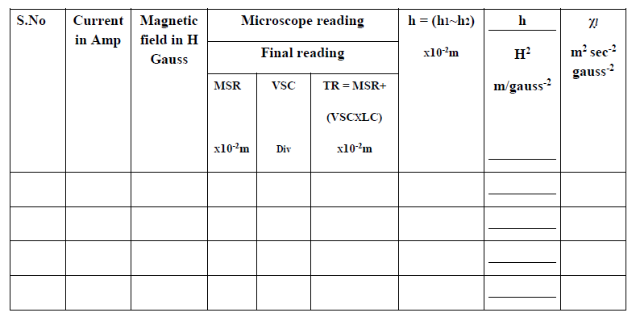

**RESULT**

The magnetic susceptibility of the given liquid χ*l*= ----------------- m2 sec-2 gauss-2

**Ex.No. :4 DETERMINATION OF ENERGY GAP OF A**

**SEMICONDUCTOR DIODES**

**AIM**

To determine the width of the forbidden energy gap in a semiconductor material taken in the form of p-n-junction diode.

**APPARATUS REQUIRED**

015V dc power supply, diode with heating arrangement, thermometer (0-100°C), voltmeter (0-12V), a microammeter (0-100μA).

**FORMULA**

The width of the forbidden energy gap is given by

$$E_{g}=\frac{2.30×2×k×slope}{1.6×{10}^{-16}}eV$$

$$E_{g}=3.973×{10}^{-4}×slopeeV$$

Where,

Eg-is the band gap energy in eV

k-Boltzmann constant=1.38x10-23 J/K

slope is calculated from the graph

0-12V

0-100μA

**V**

**μA**

3V

**Oil**

**CIRCUIT DIAGRAM**

The diode kept in the oil bath is reverse biased with the help of DC voltage obtained from a DC power supply and the current that flows through the reverse biased diode is measured with a micro ammeter. A heating system helps to raise the temperature of the diode.

**PROCEDURE**

The diodeis immersed in an oil bath that in turn is kept in a heating mantel. A thermometer is also kept in the oil bath such that its measure bulb is just at the height of diode. The diode terminals are connected with voltmeter and ammeter as shown in the figure. The power supply is switched on and the voltage is adjusted is adjusted (say 5 volts). The current through the diode and the room temperature are noted. The power supply is switched off and the heating mantle is switched on. The oil bath is heated up to 65°C. The oil is stirred well. The temperature of oil bath stabilized say at 75°C. The power supply is again switched on and the voltage is kept at 5V. The temperature (say 75°C) and the corresponding current through the diode are noted.

Now the oil bath is allowed to cool slowly. As the temperature falls, the current through the diode decreases. The current fall for various temperatures (any convenient interval) are noted down. The calculations are completed and a graph is plotted taking 1000/T on X-axis and log I0 on Y-axis. A straight line is obtained as shown in the figure, slope of the straight line is determined and using it the band gap is calculated using the following equation.

$$E_{g}=3.973×{10}^{-4}×slopeeV$$

Care should be taken while performing the experiment, the diode and the thermometer are placed at the same level in the oil bath. The maximum temperature of the diode should not go beyond 80°C. Reading of the current and temperature to be taken simultaneously.

**TO DETERMINE THE BAND GAP IN A SEMICINDUCTOR DIODE**

|  |  |  |  |  |  |
| --- | --- | --- | --- | --- | --- |
| S.No. | Current I0μA | Temperature t°C | Temperature T= (t+273)K | 1/Tx10-3 | Log I0 |
|  |  |  |  |  |  |
|  |  |  |  |  |  |

**RESULT**

The width of the forbidden energy gap in a semiconductor diode=

**Ex.No. :5 MEASUREMENT OF SPEED OF LIGHT IN WATER MEDIUM**

**– MINIMUM DEVIATION FROM A PRISM**

**AIM**

To determine the speed of light in water medium by minimum deviation.

**APPARATUS REQUIRED**

Spectrometer, hollow prism, reading lens, sodium vapor lamp, prism stand etc.

**FORMULA**

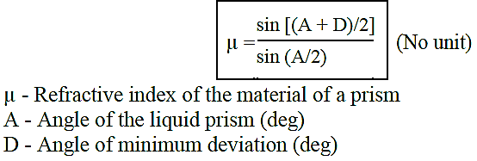

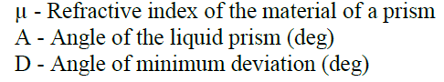

**(60°)**

$$V=\frac{C}{μ} m/s$$

**V- Speed of light in medium**

**C –Speed of light in air (3x108m/s)**

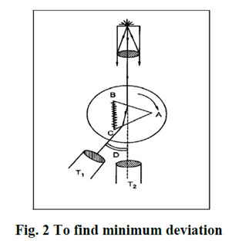

**Minimum Deviation of liquid prism**

**PROCEDURE**

To start with, the following preliminary adjustments should be made.The eyepiece of the telescope is moved to and fro until the crosswires are clearly seen. The telescope is adjusted to receive parallel rays by turning it towards a distant object and is adjusted to get a clear image of the distant object on the cross wires. The telescope is brought in line with the collimator. The slit is opened slightly and the image of the slit is viewed through the telescope and the length of the collimator is adjusted till a clear well-defined image of the slit is obtained. Leveling the prism table by using a spirit level and leveling screws. The vertical cross wire of the telescope should coincide with the vertical slit.

**TO DETERMINE ANGLE OF MINIMUM DEVIATION (D)**

Rotate the prism table in such a way that one refracting face of the liquid prism faces the collimating lens as shown in the figure. Rotate the telescope and view the refracted image through telescope. Viewing the refracted image through telescope, rotate the prism-table slowly in such a direction that the image of the slit shifts towards the direction of the incident ray. It will be found that for one particular position of the liquid prism, the image just retraces its path. Adjust the telescope so that the image of the slit just touches the vertical cross wire. Now the liquid prism is in minimum deviation position. Note the readings of verniers A and B. Remove the liquid prism and turn the telescope to get the direct image of the slit. Note the direct ray reading of both verniers. The difference in vernierA readings of the minimum deviation position and direct ray will be give the angle of minimum deviation. Similarly vernier B differences are found.

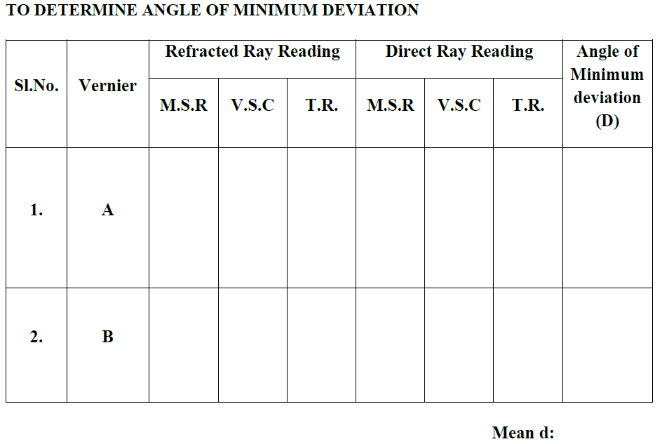

**RESULT**

Angle of minimum deviation (D) =

Refractive index of the liquid prism (μ) =

Speed of light in water medium (V)=

**Ex.No.:6 DETERMINATION OF THERMAL CONDUCTIVITY OF BAD**

**CONDUCTOR-LEE’S DISC METHOD**

**AIM**

To determine the thermal conductivity of a bad conductor by lee’s disc method

**APPARATUS REQUIRED**

Lee’s disc apparatus, Bad conductor (thin cardboard or glass disc of uniform thickness) , Two thermometers, Steam boiler, Heater, Stop watch, Screw gauge, Vernier caliper, Balance.

**FORMULA**

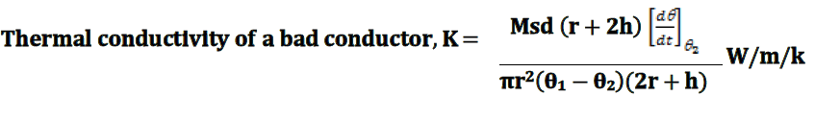

**Where,**

M -mass of the metal disc in kg

S – specific heat capacity of the material of the disc in Jkg-1K-1

d –thickness of a bad conductor in m

r – radius of the metallic disc in m

h – thickness of the metal disc in m

θ1 –steady state temperature of the steam chamber in °C

θ2-steady state temperature of the metal disc in°C

- rate of cooling at steady state temperature θ2 in °CS-1

**PROCEDURE**

Lee’s disc apparatus is shown in figure. It consists of a highly polished brass disc B. It is suspended by three strings from a circular ring R which is fixed to an iron stand. A circular cardboard whose diameter is the same as that of the disc is placed on the disc and over it is placed a steam chamber S. The steam chamber is also circular in shape having the same diameter as that of the disc. Holes are provided in B and S to facilitate the insertion of thermometers T1 and T2.

Steam is allowed to pass through the chamber as shown in the Fig.1. The temperatures indicated by the two thermometers will start rising. After about half an hour, a steady state is reached when the temperature of the lower disc no longer rises. At this stage, find the temperature θ2 ºC of the lower disc. Let the temperature of the steam as indicated by the thermometer in the upper chamber be θ1ºC.



**Lee’s disc arrangement**

Now, the cardboard is removed by gently lifting the upper chamber. The lower disc is allowed to be heated directly by keeping it in contact with the steam chamber. When the temperature of the lower disc attains a value of the about 10 more than its steady state temperature, the chamber is removed and the lower disc is allowed to cool down on it own accord. The time- temperature observations are taken every 30 seconds until the temperature falls to at least 5 below the steady state temperature.

The diameter (2r) and thickness (h) of the lower disc are found by vernier calipers and screw gauge respectively. The mass of the disc is found by the balance (M kg). The thickness (d) of the cardboard disc is measured by the screw gauge.

***Graph***

A graph is drawn taking time along the X axis and the temperature along the Y axis as shown in graph. From the graph, the time taken (t sec) to cool from (θ2+ ½ ) ºC to (θ2–½ ) ºC is found.

**To find the rate of cooling**

|  |  |  |
| --- | --- | --- |
| S.No | Temperature (θ°C) | Time (t) seconds |
|  |  |  |
|  |  |  |
|  |  |  |
|  |  |  |

**To find the diameter of the metallic disc (D)**

L. C. = 0.01 cm

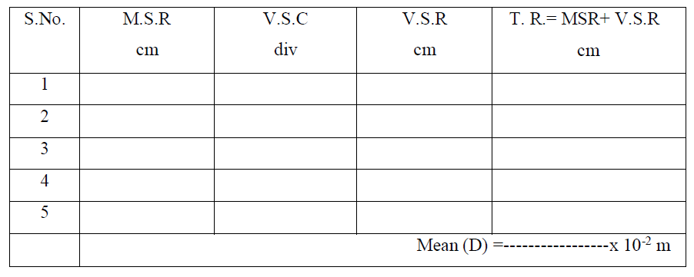

**Mean radius of the metallic disc (r) = D/2 = --------------- x 10-2m**

**To find the thickness of the card board (d)**

L.C. =0.01 mm

Zero error =---------div Zero correction= mm

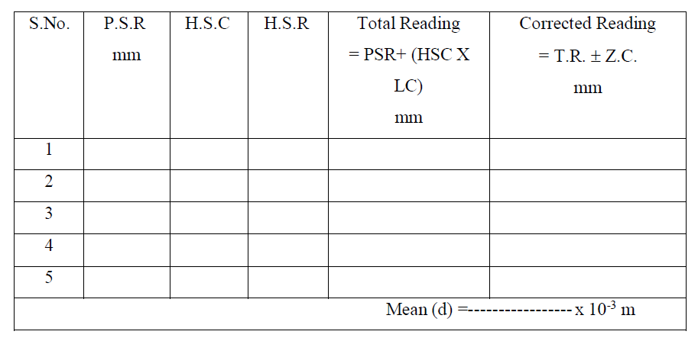

**To find the thickness of the metallic disc (h)**

L.C. = 0.01 mm

Zero error = ------div Zero correction = mm

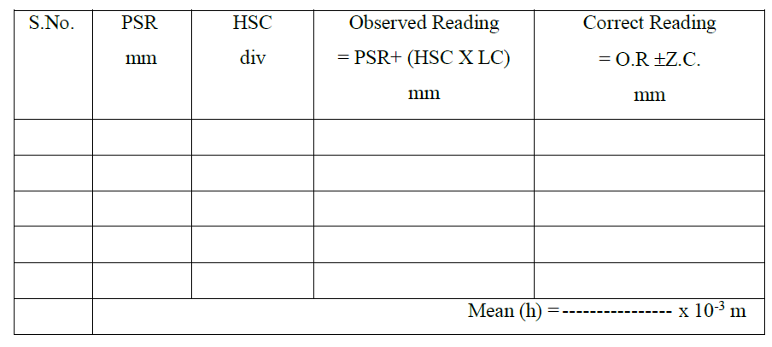

Graph

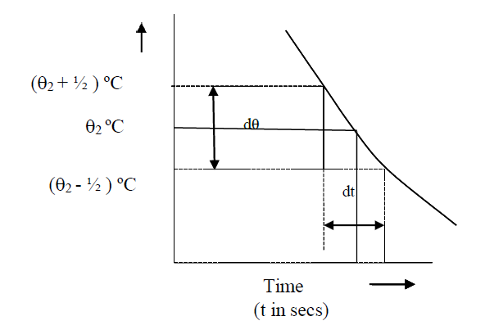

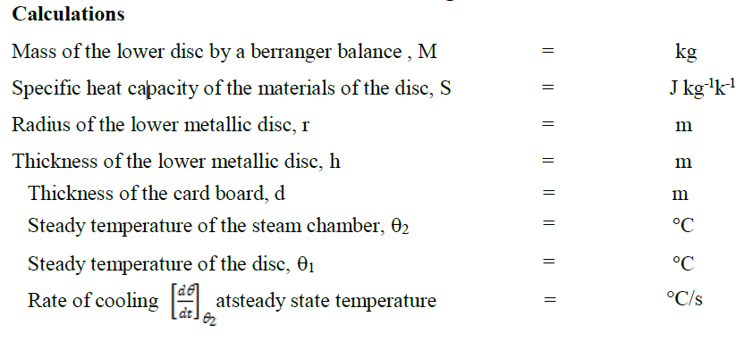

**Result**

Thermal conductivity of the bad conductor given =

**Ex.No. :7 DETERMINATION OF HALL COEFFICIENT**

**-HALL EFFECT EXPERIMENT**

**AIM**

To determine the Hall coefficient, density of charge carriers, mobility of charge carriers in a given semiconductor material and verify the variation of Hall Voltage with current by the graph.

**APPARATUS REQUIRED**

Electromagnet, Hall Effect setup, Hall probe (semiconductor n-type or p-type), constant current power supply, Gauss meter, Gauss probe.

**FORMULA**

$$Hall co-efficient \left(R_{H}\right)=\frac{V_{H}t}{IB}{10}^{8}{cm}^{3}C^{-1}$$

Where,

VH- Hall Voltage

t- Thickness of the sample

I-Applied current by Hall setup

B- Magnetic field

$$Carrier density \left(n\right)=\frac{1}{R_{H}e}{cm}^{-3}$$

Where,

RH-Hall co-efficient

e- Charge of the electron or hole

$$Carrier mobility \left(μ\right)=R_{H}σ {cm}^{2}V^{-1}{Sec}^{-1}$$

Where,

$$σ -conductivity of the sample$$

**PRINCIPLE**

When a magnetic field is applied perpendicular to a current carrying conductor, a voltage is developed across the conductor in a direction perpendicular to both the current and magnetic field. This phenomenon is known as Hall Effect.

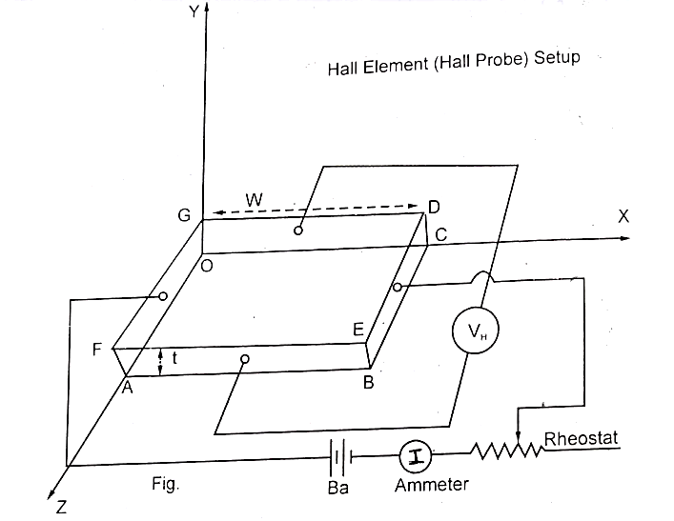

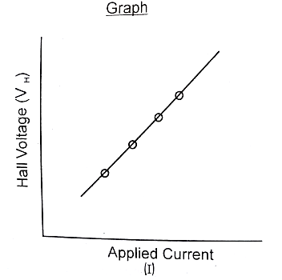

**PROCEDURE**

1. Excite the electromagnet by A.C power supply
2. Measure the magnetic field (using the probe of the gauss meter by keeping Gauss meter probe in between the poles of electromagnet) by varying the input current values in steps of 0.5 Amps and tabulate the readings.

To measure the Hall Voltage

1. Connect the Width-wise contacts of the Hall probe in the Hall Effect setup to the terminals on the voltage side marked as V (This is done to measure the potential difference along the width) and length-wise contacts of the Hall probe in the Hall effect setup to the terminals on the current side marked as I ammeter)This is done to measure the current along the length). This is shown in figure 1.
2. Switch ON the Hall Effect setup and turn the selector switch over Knob to the current side and set the current to 2mA.
3. Turn the selector switch over Knob to the voltage side and place the Hall probe in between the poles of electromagnet.
4. Rotate the Hall probe until it becomes perpendicular to the magnetic field.
5. Measure the Hall Voltage from the digital panel meter of Hall setup by varying the input current values as done above and tabulate the readings.
6. From the data, calculate the Hall co-efficient, carrier density and carrier mobility.
7. Draw a graph by taking the different input current values along the X-axis and the corresponding Hall voltage along the Y-axis.

**Observation**

Thickness of the sample t=------cm

Resistivity of the sample ρ=------VC-1 sec cm

Conductivity of the sample σ=1/ ρ= --------CV-1 Sec-1 cm-1

**Measurement of Hall Voltage by Hall setup:**

Current in Hall Effect setup = -----------mA

|  |  |  |  |  |
| --- | --- | --- | --- | --- |
| S.No. | Applied Current (I) by power supply of E.m (Amp) | Magnetic Field (B) Gauss | Hall Voltage (VH) m Volt | Hall Coefficient (RH)= (VHt/IB) 108 cm3 C-1 |
|  |  |  |  |  |
|  |  |  |  |  |
|  |  |  |  |  |

**RESULT**

The Hall Effect is observed in the given specimen and allied parameters are calculated.

1. Hall Co-efficient (Rh)= --------cm3C-1
2. Carrier density (n)=-------------cm3
3. Carrier mobility (µ)=-----------cm2V-1sec-1
4. Graph is draw between Hall Voltage and applied current.

**Ex.No.:7 DIFFRACTION GRATING USING SPECTROMETER**

**– DETERMINATION OF WAVELENGTH OF LIGHT**

**AIM**

To determine the wavelength of the prominent mercury spectral lines using grating by minimum deviation method.

**APPARATUS REQUIRED**

Spectrometer, diffraction grating, mercury vapor lamp, reading lens.

**FORMULA**

At the minimum deviation position, the grating equation for the nth order spectrum is

$$nλN=2\sin{θ/2}$$

Thus with a known wavelength 𝛌, the number of lines per unit length is given by

$$N=\frac{2 \sin{θ/2}}{nλ}$$ and knowing N, the wavelength of the spectral line can be determined by measuring the angle of diffraction at the minimum deviation position Ɵ, by using the formula (n=1)

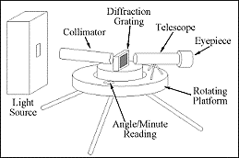

<https://www.gopracticals.com/physics/physics-wavelength-diffraction-grating/>

**PROCEDURE**

The least count of the spectrometer is noted. Mercury vapour lamp is used as light source and the preliminary adjustments of the spectrometer are carried out. The grating is fixed on the grating table such that the light through the collimater falls almost normally on it. Now the diffraction spectra can be observed on the direct beam.The Vernier table is clamped. The telescope is brought against the direct beam, the cross wire is coincided with the silt and the reading are noted.The telescope is brought against the first order green line (𝛌=546.1 nm) on the left side of the direct beam. Looking through the telescope, the grating table is turned slowly towards right (anticlockwise) so that the image of the slit moves towards direct beam side, and then begins to return. This retracing point corresponds to the position of minimum deviation. The cross wire of the telescope is adjusted to coincide with the slit at the retracing point and the readings are noted. The difference of this diffracted readings with the direct ray given the angle of diffraction.The telescope is then brought to the right of the direct beam. With the first order green line in the field of view of the telescope, rotate the grating table towards left (clockwise) and locate the minimum deviation position (retracing point) of the slit. Consider the wire on the slit and the spectrometer reading are noted. The angle of diffraction is found.The mean value of angle of diffraction is found Ɵ, from which the number of lines per unit length is calculated by

$$N=\frac{2 \sin{θ/2}}{nλ}$$

The experiment is repeated for second order green line for both left and right of the direct beam and the value of N is calculated.The cross wire of the telescope is brought against different prominent mercury lines in the first order and in each case, the diffracting angle at the minimum deviation position is determined. Then the wavelength of each line can be calculated by (n=1)

$$λ=\frac{2 \sin{θ/2}}{N}$$**OBERVATION**

**To find the least count of the spectrometer**

To find the number of lines per meter of the grating (N)

Wavelength of the spectral lines used (green) 𝛌= -----m

|  |  |  |  |  |  |  |  |  |
| --- | --- | --- | --- | --- | --- | --- | --- | --- |
| Vernier | Order n | Spectrometer reading  MSR +VSR x LC | | | Angle of diffraction T2~T1 | | | $$N=\frac{2 \sin{θ/2}}{nλ}$$ |
| Direct T1 | Refracted T2 | | Left | Right | Mean |
| Left | Right |
| Ver. I  Ver.II |  |  |  |  |  |  |  |  |
| Ver. I  Ver.II |  |  |  |  |  |  |  |  |

**To find the wavelength**

|  |  |  |  |  |  |  |  |  |  |
| --- | --- | --- | --- | --- | --- | --- | --- | --- | --- |
| Order of the spectrum  n | Vernier | Spectral line | Spectrometer reading  MSR +VSR x LC | | | Angle of diffraction T2~T1 | | | $$λ=\frac{2 \sin{θ/2}}{N}$$ |
| Direct T1 | Refracted T2 | | Left | Right | Mean |
| Left | Right |
|  | Ver. I  Ver.II | Violet |  |  |  |  |  |  |  |
|  | Ver. I  Ver.II | Blue |  |  |  |  |  |  |  |
|  | Ver. I  Ver.II | Green |  |  |  |  |  |  |  |
|  | Ver. I  Ver.II | Yellow |  |  |  |  |  |  |  |
|  | Ver. I  Ver.II | Red |  |  |  |  |  |  |  |

**RESULT**

The wavelength of the prominent mercury spectral line are calculated.